Hardware 2: secondary storage and buffers
Y12 - Cambridge International 9618 | 3.1 | Student booklet
Name: _______________________________ | Date: _____________

This booklet has everything you need for the lesson in one place. Work through it in order:
- Learn sections show the key slides. Read them carefully - they explain the ideas and show worked examples.
- Task sections are where you practise. Each task uses what the slides just before it taught you.
- Tasks build up from recall to real Cambridge 9618 Paper 1 questions. Task 5 is homework.
Learn Starter - recap of Hardware 1
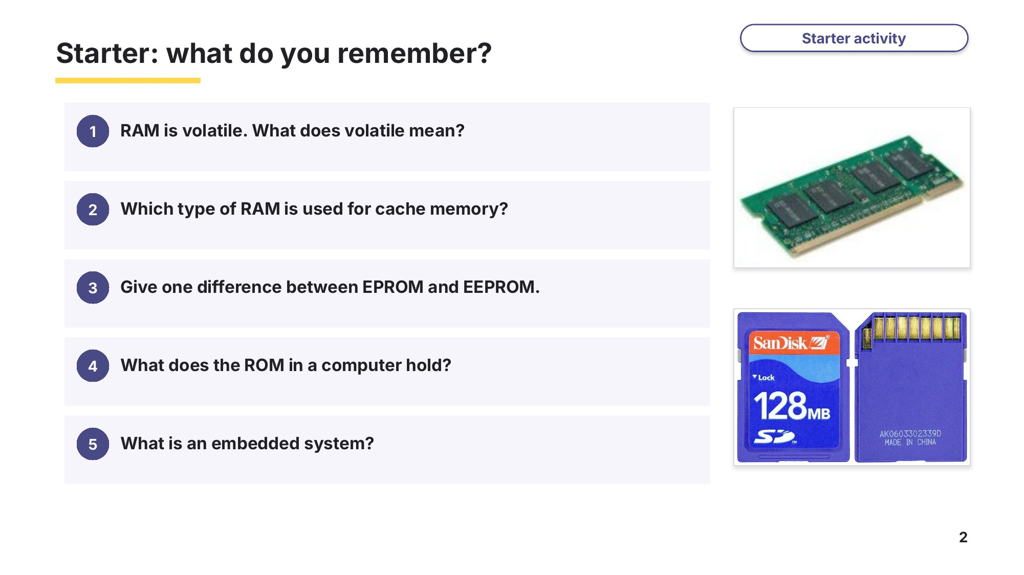
Slide 2 - Starter: what do you remember?
Task 1 Starter: what do you remember? [5 marks]
Question | Answer
1 RAM is volatile. What does volatile mean?
2 Which type of RAM is used for cache memory?
3 Give one difference between EPROM and EEPROM.
4 What does the ROM in a computer hold?
5 What is an embedded system?

Learn Magnetic hard disks
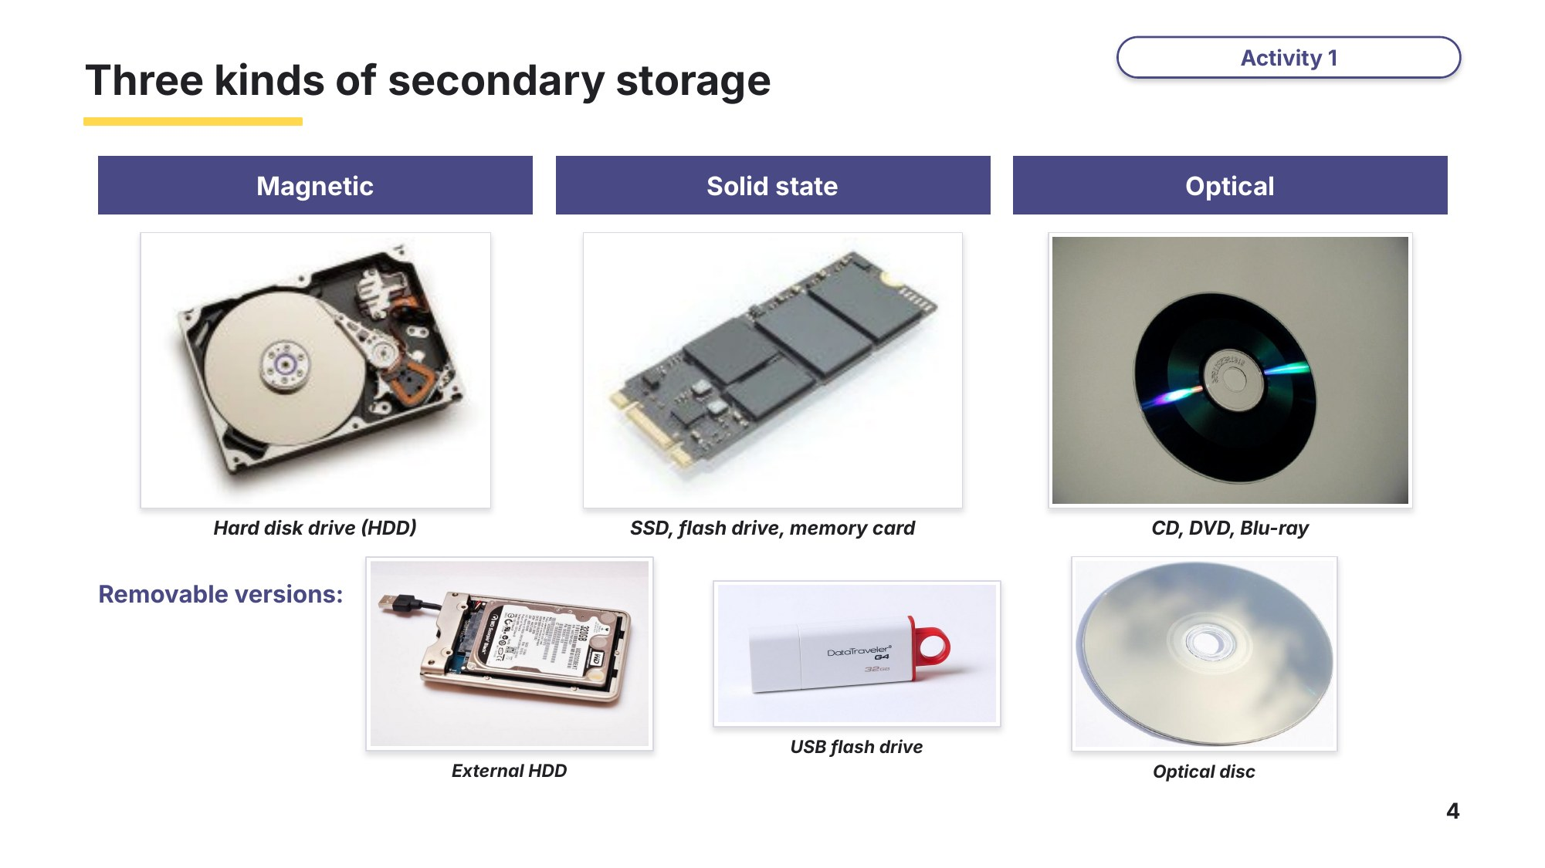
Slide 4 - Three kinds of secondary storage
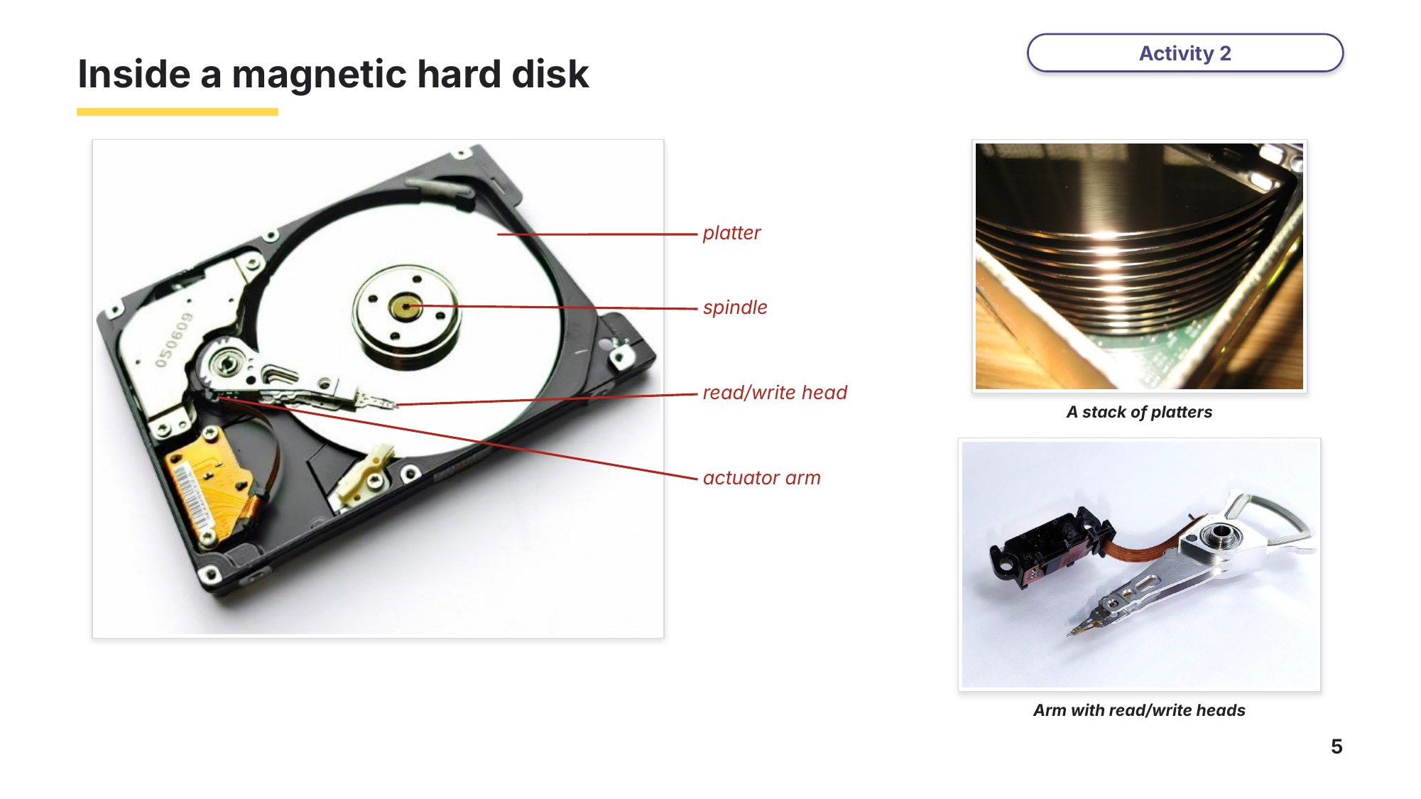
Slide 5 - Inside a magnetic hard disk
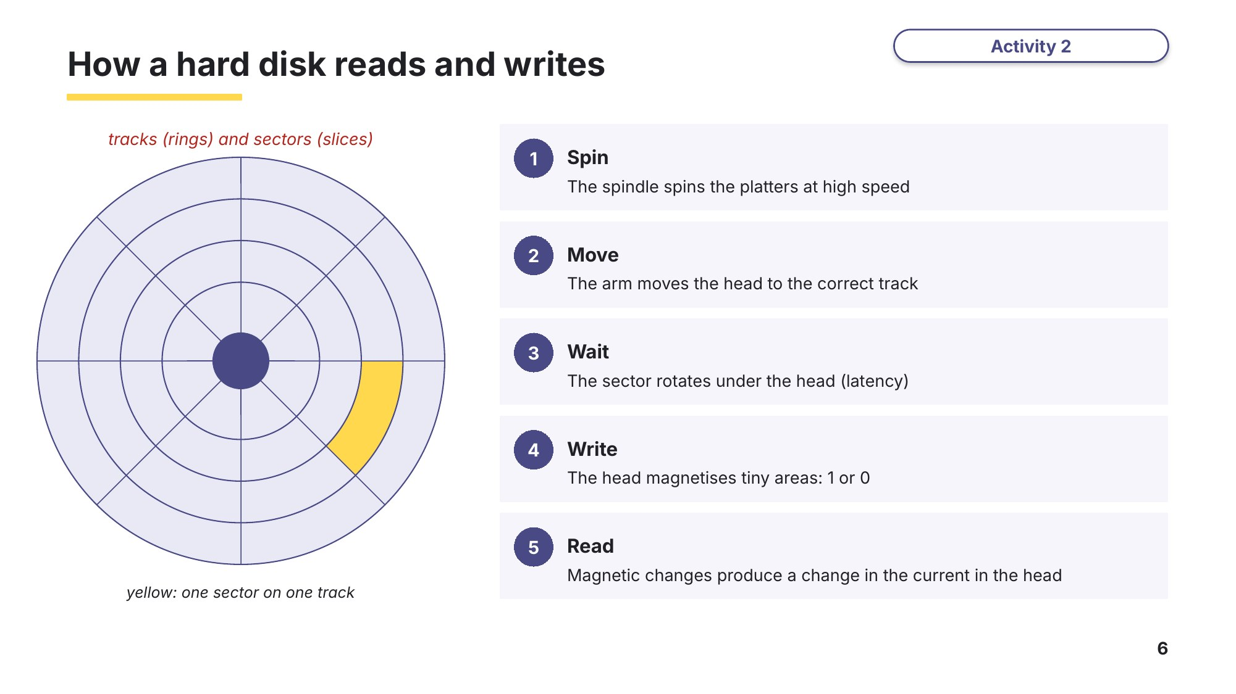
Slide 6 - How a hard disk reads and writes
Task 2 Magnetic hard disk [5 marks]
(a) Number these steps 1 to 5 to show how a hard disk writes data. [3]
Step | Order
The read/write head magnetises tiny areas of the surface
The spindle spins the platters at high speed
The correct sector rotates under the head
The actuator arm moves the read/write head to the correct track
The areas are magnetised in one of two directions to store 1s and 0s

(b) Over time, the files on a hard disk become fragmented. Explain why this makes the hard disk slower. [2]

Learn Solid state memory
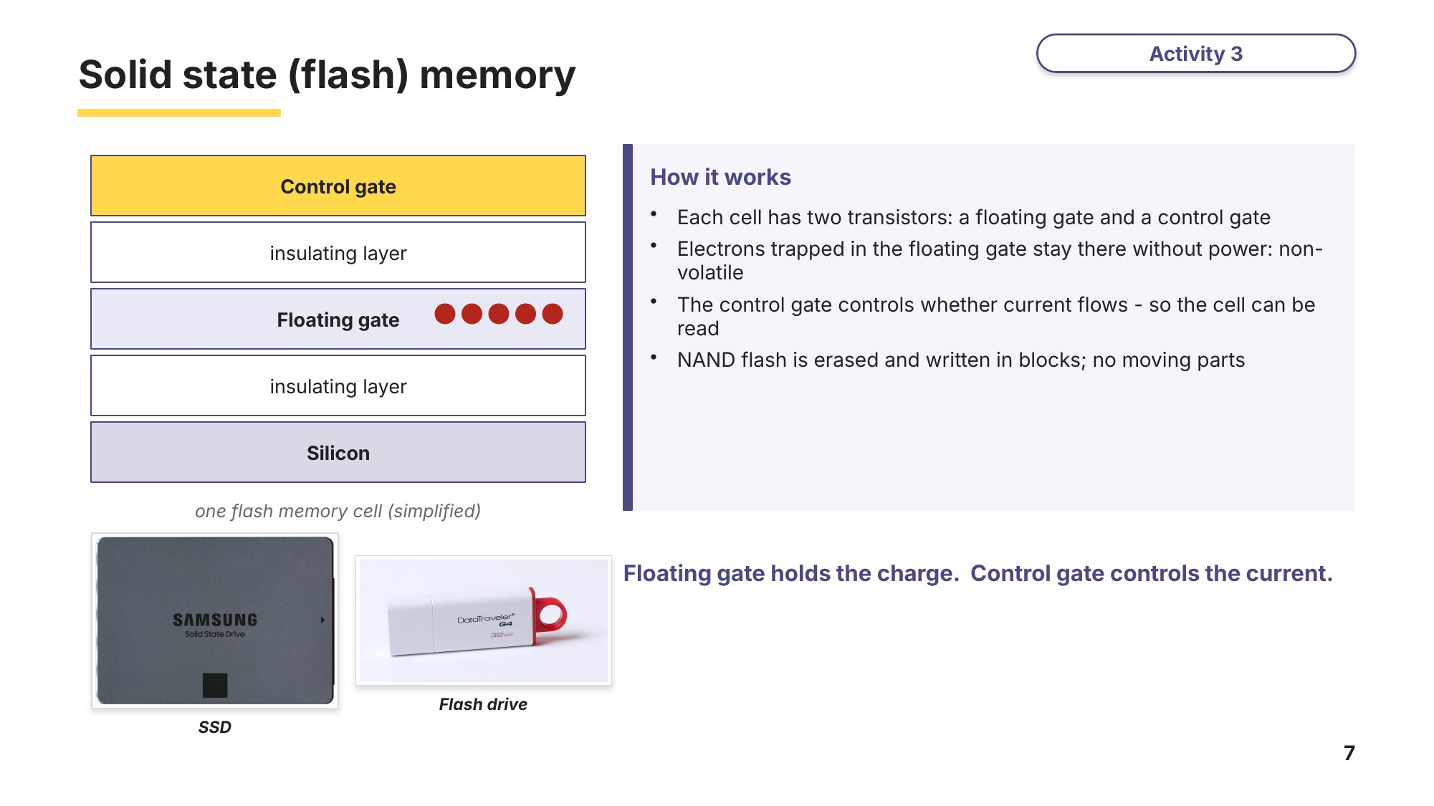
Slide 7 - Solid state (flash) memory
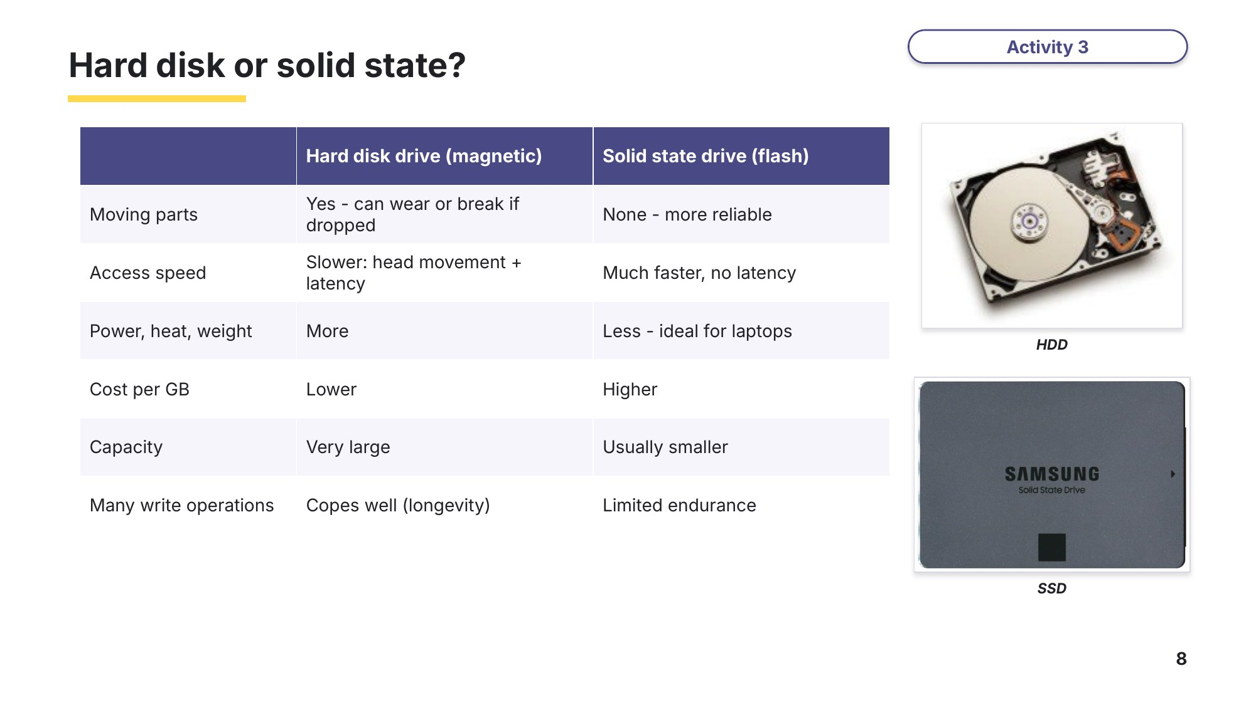
Slide 8 - Hard disk or solid state?
Task 3 Solid state or magnetic? [6 marks]
(a) Write HDD or SSD next to each statement. [4]
Statement | HDD or SSD?
Data is stored by trapping electrons in a floating gate
It has no moving parts, so it is more robust if dropped
It is cheaper per gigabyte
Data access is slowed by the time for the disk to rotate (latency)

(b) A shop records CCTV video all day, every day, and keeps it for six months. Identify the more suitable type of storage and give one reason. [2]

Learn Optical discs and buffers
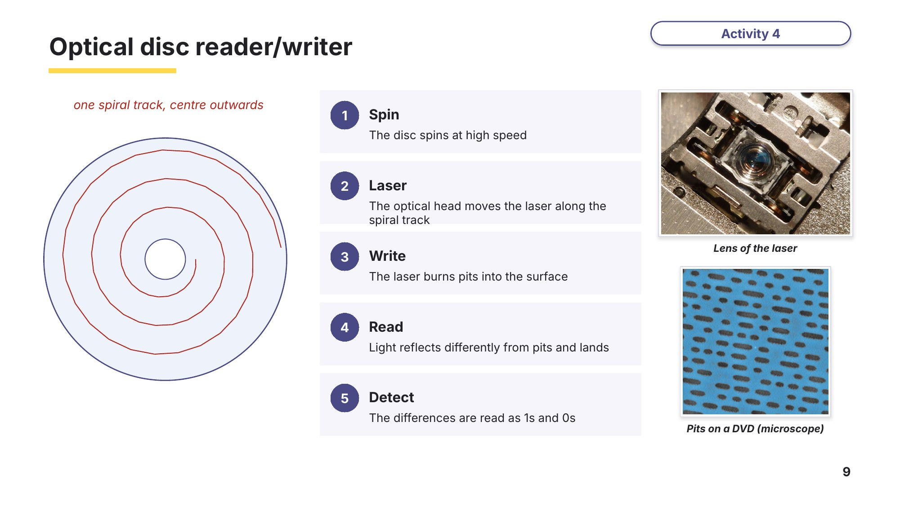
Slide 9 - Optical disc reader/writer
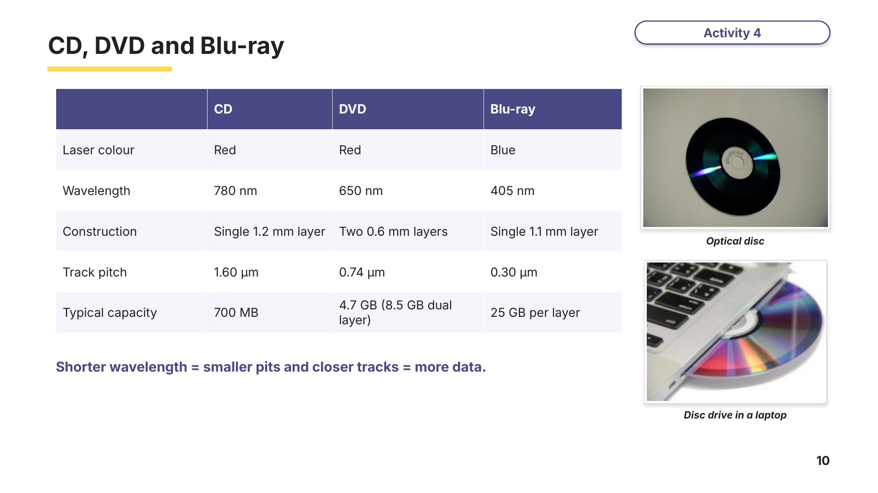
Slide 10 - CD, DVD and Blu-ray
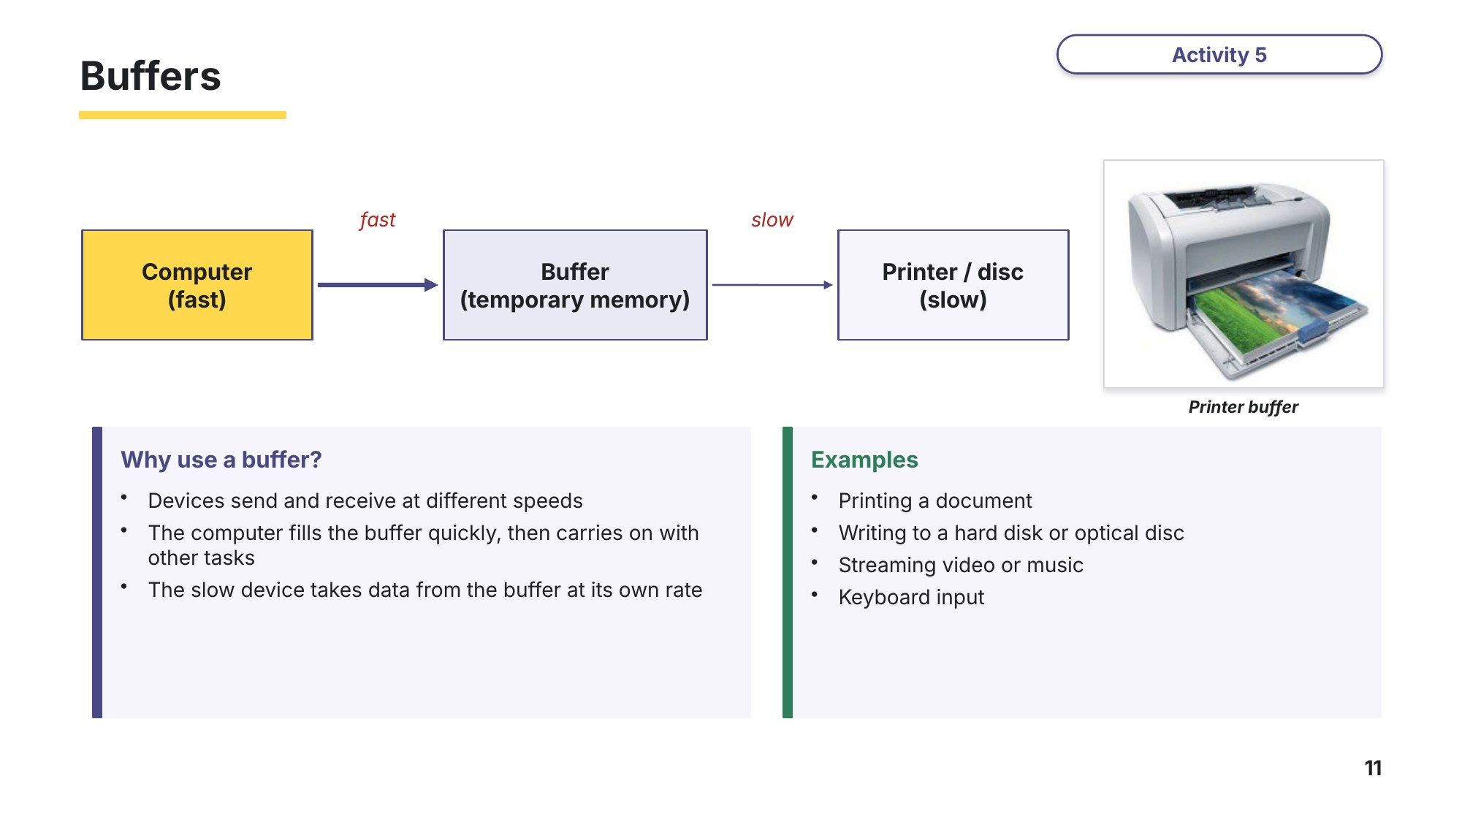
Slide 11 - Buffers
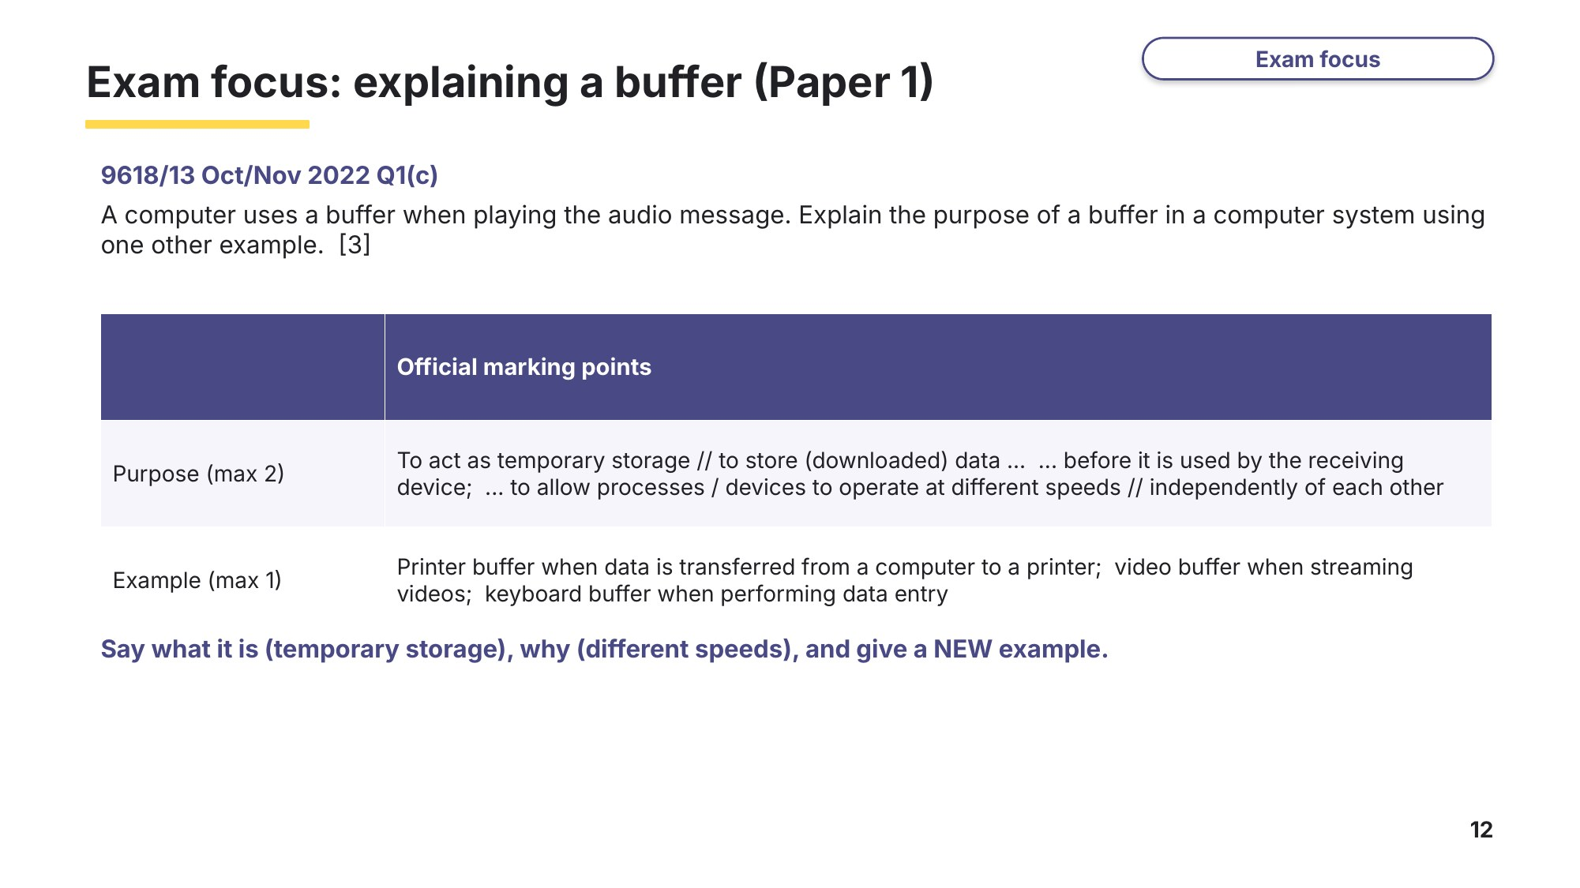
Slide 12 - Exam focus: explaining a buffer (Paper 1)

Task 4 Optical discs and buffers [6 marks]
(a) Write CD, DVD or Blu-ray next to each statement. [3]
Statement | CD, DVD or Blu-ray?
Uses a blue laser with a wavelength of 405 nm
Uses two 0.6 mm layers
Has the largest distance between tracks (track pitch)

(b) Explain why a computer uses a buffer when it sends a document to a printer. [3]

Task 5 Real exam questions - homework [25 marks]
All questions are from Cambridge 9618 Paper 1.
(a) Complete the description of the principal operation of a magnetic hard disk by writing the missing words. [4]
9618/11 May/June 2025 Q6(a)(i).
The magnetic hard disk has one or more ................................................ that can be magnetised.
These are mounted on a ................................................ and rotate at high speed.
A ................................................ is moved across the surface on an arm.
When data is read, the changes in the ................................................ produce a change in the electric current.
A video doorbell has both primary memory and secondary storage. The secondary storage is a solid state device.
(b) (i) Complete the table by writing the answer or answers to each statement. [4]
9618/11 May/June 2024 Q2(c)(ii).
Statement | Answer(s)
The two types of logic gate that can be used to create solid state devices
The number of transistors contained in each cell
The type of gate that can retain electrons without power
The type of gate that allows or stops current from passing through
(ii) The video doorbell uses a buffer. The camera records video, which can be watched on a smartphone. Describe how the video doorbell will use the buffer. [2]
9618/11 May/June 2024 Q2(c)(iii).

A networked CCTV system in a house uses sensors and cameras to detect and track a person and record a video of their movements. Data from the cameras is transmitted to a central computer. The central computer stores the video files on secondary storage.
(c) Describe two reasons why magnetic storage is more appropriate than solid state storage for this computer. [4]
9618/11 May/June 2023 Q4(b).
1

2

A computer system stores data received from a temperature sensor every five seconds. The data is stored on an optical disc using an optical disc reader/writer.
(d) (i) Describe the principal operation of an optical disc reader/writer. [4]
9618/11 October/November 2024 Q3(d)(i).

(ii) The computer uses a buffer when writing data to the optical disc. Explain the use of a buffer when writing data to the optical disc. [3]
9618/11 October/November 2024 Q3(d)(ii).

A memory buffer uses Dynamic RAM (DRAM).
(e) Explain how a memory buffer is used when a computer is transferring data to its magnetic hard disk drive. [4]
9618/13 October/November 2024 Q2(b).

Learn Review
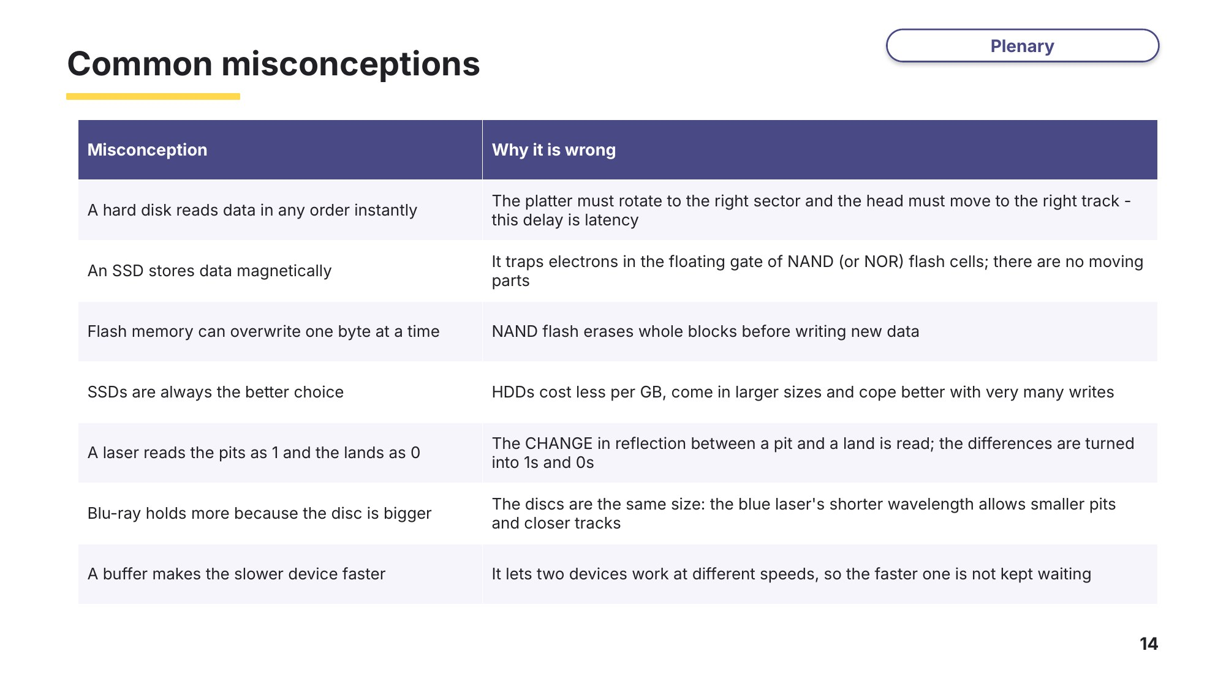
Slide 14 - Common misconceptions
Exit question
(a) Describe two steps in how a magnetic hard disk reads or writes data. [2]

(b) Which gate in a flash memory cell keeps the electrons when the power is off? [1]

(c) Explain why a computer uses a buffer when printing. [2]

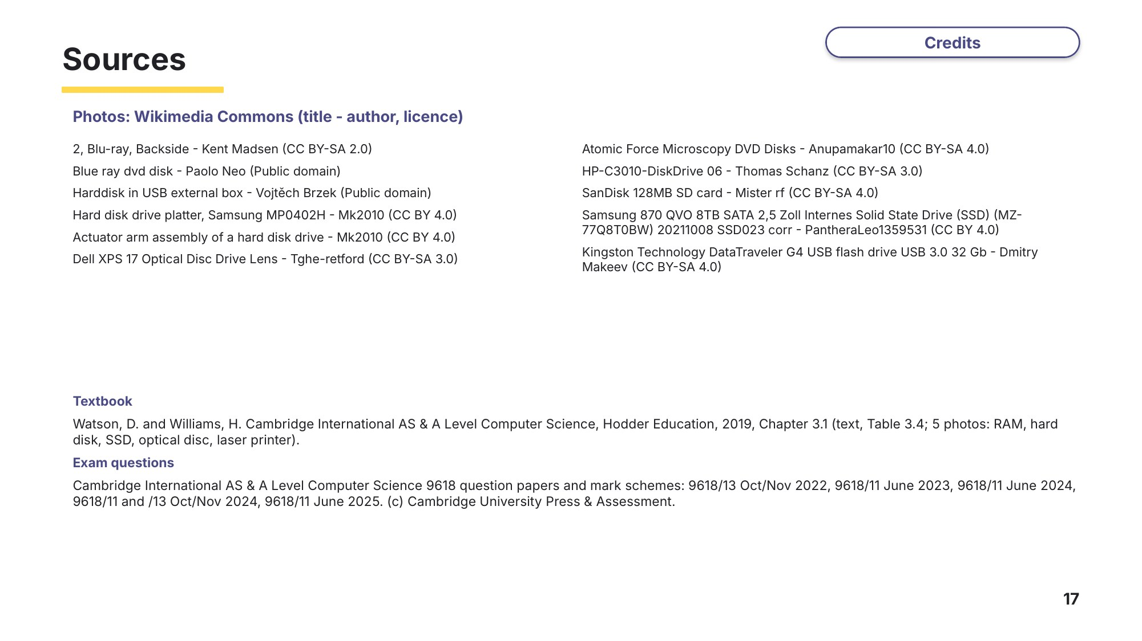
Slide 17 - Sources

